That was incredibly impressive. I did a whole heap of paintings and got the curator to come and see them
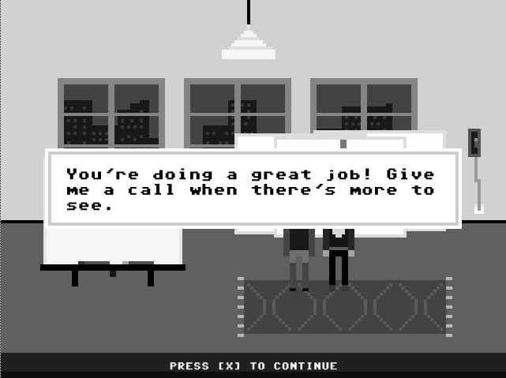
Decided to just keep ringing her.
She came twice and told me that I needed to do more but I just rang her again. Then she said she would just show the one she chose at the beginning. I was impressed (it was my best work too, by the way).
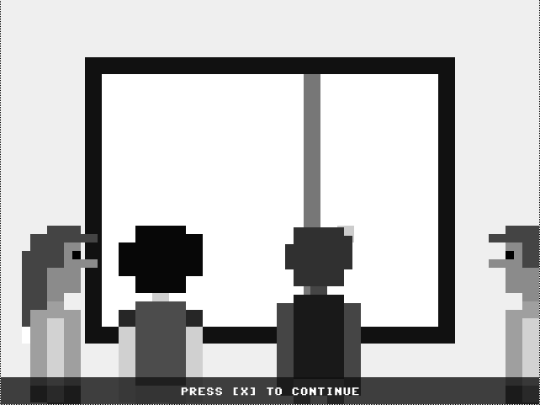
As you can see. Well you could if that idiot next to me would move his head
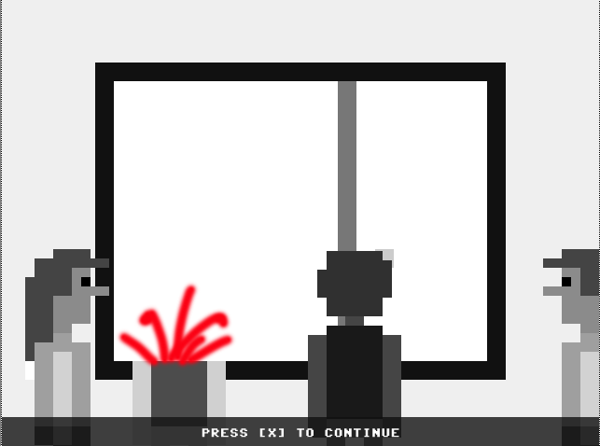
That’s better.
So nothing new. Worked well and really enjoyed making lots of paintings. Not entirely sure how I made the paintings as I never really worked out what that snake thing was doing or why it stopped doing it!

More possible comments:
This is such a powerful piece, dynamic without being oppressive.
I’ve always admired your practice and this is one of your most exciting projects
These works are stunning, would you be too insulted if I just asked you to go that little bit further with them.

